Course Title: Agentic AI

Assignment Title: N8N Prompt Engineer Workflow

Submitted To: Miss Muskan Atiq

Submitted By: Fatima Hussain

Student ID: AGI-918851

Submission Date: November 2, 2026

n8n Prompt Engineer Workflow - System Documentation:

This project implements an automated AI Workflow in n8n that functions as a specialized Prompt Engineer. The workflow receives raw, unstructured inputs from a user and transforms them into high-quality, structured prompts tailored for a specific domain (Complaint Management). It then utilizes Google Gemini to generate precise, professional responses

Workflow Architecture & Core Nodes:
The workflow consists of three primary components connected in sequence:

Node 1: n8n Chat Trigger (When chat message received):
  - Role: Acts as the entry point and interface for the user.
  - Functionality: Captures real-time text input provided by the user in the n8n chat window and passes it downstream into the execution pipeline.

Screen shoot:

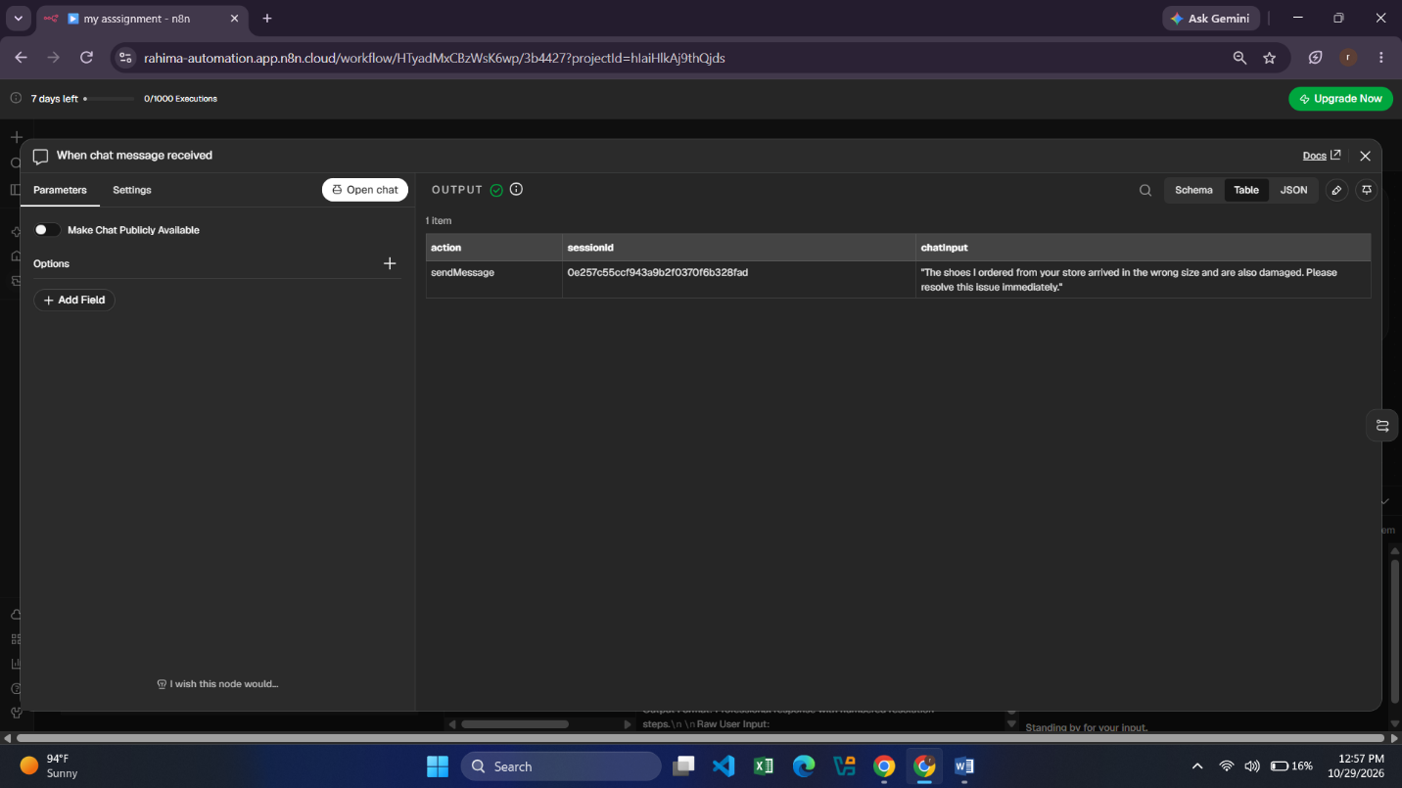

Node 2: Basic LLM Chain (Prompt Engineer Node):
- Role: Serves as the central intelligence node that applies prompt engineering principles.
- Functionality: It holds a specialized System Prompt for Complaint Management. When raw user input is received, this node restructures it according to set parameters—defining the issue severity, enforcing an empathetic and objective tone, and structuring clear action steps.

Screen shoot:

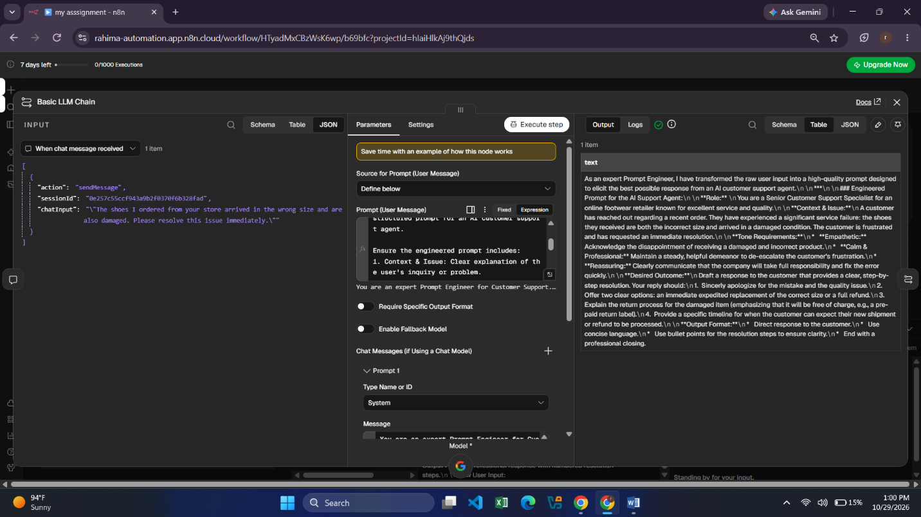

Prompt For Support:
You are an expert Prompt Engineer for Customer Support.
Your task is to take the user's raw input and rewrite it into a clear, polite, and well-structured prompt for an AI customer support agent.

Ensure the engineered prompt includes:
1. Context & Issue: Clear explanation of the user's inquiry or problem.
2. Tone Requirements: Empathetic, calm, professional, and reassuring.
3. Desired Outcome: Specific instructions on providing a step-by-step solution or helpful reply.
4. Output Format: Direct response with concise formatting (bullet points if needed).

Raw User Input: {{$json.chatInput}}

Propmt For Complaint:
System: You are an expert Prompt Engineer specializing in Complaint Management.
Your task is to take a user's raw complaint or negative feedback and rewrite it into a structured, clear, and high-priority prompt for an AI agent handling complaints.

Ensure the engineered prompt includes:
1. Issue Breakdown: Identify the exact complaint, root cause, and severity level.
2. Tone Requirements: Apologetic, serious, objective, and conflict-de-escalating.
3. Action Plan: Clear instructions to offer immediate remedies, compensation/refund policy options, or escalation steps.
4. Output Format: Professional response with numbered resolution steps.

Final Result: Execution & Validation
As verified in the test execution logs:
- Triggering: The chat window receives input from the user session.
- Processing: The input travels seamlessly through Basic LLM Chain to Google Gemini.
- Output Generation: The workflow successfully outputs structured complaint transformations and resolution frameworks without errors (indicated by green success status indicators across all nodes).

